ΘΕΜΑ/ΣΤΟΧΟΣ ΜΟΥ ->> PROJECT PROPOSAL PPT. FIND INSTRUCTION BELOW IN GREEK AND ENGLISH. Ενδεικτική λίστα περιεχομένων τελικής αναφοράς
Ενδεικτική λίστα περιεχομένων τελικής αναφοράς
Εξώφυλλο
1 - Εισαγωγή
2 - Ανάλυση του προβλήματος
3 - Έρευνα πιθανών λύσεων
4 - Μεθοδολογία υλοποίησης
5 - Σχεδιασμός - Αρχιτεκτονική
6 - Υλοποίηση
7 - Δοκιμές και έλεγχος
8 - Αξιολόγηση
9 - Συμπεράσματα
Πηγές
Παράρτημα: Product backlog (Απαιτήσεις στο Trello ή παρόμοιο λογισμικό)

ΝΑ ΒΡΩ 30 ΠΗΓΕΣ ΓΙΑ ΝΑ ΣΤΗΡΙΞΩ ΕΠΙΣΤΗΜΟΝΙΚΆ ΤΑ ΕΡΓΑΛΕΙΑ, ΜΕΘΟΔΟΥΣ, ΚΑΙ ΤΙ ΑΚΡΙΒΩΣ ΤΕΧΝΟΛΟΓΙΕΣ ΘΑ ΧΗΣΙΜΟΠΟΙΗΣΩ ΚΑΙ ΝΑ ΚΑΤΑΛΗΞΕΙ ΑΡΓΟΤΕΡΑ ΜΕ ΣΧΕΔΙΑΣΜΟ ΠΟΥ ΘΑ ΑΚΟΛΟΥΘΗΣΕΙ Η ΚΑΤΑΣΚΕΥΗ ΕΝΟΣ ΠΡΟΤΟΤΥΠΟΥ ARTIFACT LEGAL ANONYMIZER TOOL ΣΕ PYTHON.
Σε παρακαλώ θα χρειαστώ να κάνουμε ερευνα μαζί με rated αποδεκτα απο την κοινοτητα peer ΕΡΕΥΝΑΣ ΤΟ ΑΠΟΤΕΛΕΣΜΑ ΘΑ ΕΙΝΑΙ ΜΙΑ ΠΑΡΟΥΣΙΑΣΗ ΕΝΟΣ ΤΕΤΑΡΤΟΥ 15 ΛΕΠΤΩΝ. ΠΡΏΤΑ ΒΡΙΣΚΟΥΜΕ ΤΟ ΠΡΟΒΛΗΜΑ.
ΣΤΗΝ ΠΕΡΙΠΤΩΣΗ ΜΟΥ ΕΙΝΑΙ ΑΝΟΝΥΜΙΖΕ LEGAL DOCUMENTS.
ΘΑ ΣΟΥ ΔΩΣΩ ΤΙΣ ΟΔΗΓΙΕΣ ΠΑΡΑΚΑΤΩ ΚΑΙ ΦΩΤΟΓΡΑΦΙΕΣ ΚΑΙ ΕΓΓΡΑΦΑ ΝΑ ΑΝΑΛΥΣΕΙΣ ΚΑΙ Η ΔΟΥΛΕΙΑ ΣΟΥ ΕΙΝΑΙ ΝΑ ΣΧΕΔΙΑΣΟΥΜΕ ΜΑΖΙ ΤΟ ΠΩΣ ΘΑ ΤΟ ΚΑΝΟΥΜΕ ΜΕ ΒΑΣΗ ΜΟΝΟ ΤΙΣ ΕΠΙΒΕΒΑΙΩΜΕΝΕΣ ΜΕΤΑΞΥ ΜΑΣ ΠΗΓΕΣ. ΕΝΑ ΕΙΔΟΥΣ ΣΥΝΕΡΓΑΣΙΑΣ ΔΗΛΑΔΗ. ΣΑΝ ΒΟΗΘΗΜΑ ΤΟ ΟΠΟΙΟ ΜΕΤΑ ΘΑ ΓΙΝΕΙ ARTIFACT ΚΑΙ ΚΩΔΙΚΑΣ. ΑΡΑ ΓΙΑ ΤΗΝ ΩΡΑ ΘΕΛΩ ΜΟΝΟ ΤΟΝ ΣΧΕΔΙΑΣΜΌ ΠΟΥ ΘΑ ΑΚΟΛΟΥΘΗΘΕΙ ΒΑΣΗ ΜΟΝΟ ΤΩΝ ΠΗΓΩΝ ΠΟΥ ΘΑ ΒΡΟΥΜΕ (30) ΕΓΩ ΣΟΥ ΑΝΕΒΑΖΩ 2-4 ΠΗΓΕς ΠΟΥ ΕΓΩ ΒΡΕΙ ΓΙΑ ΝΑ ΞΕΚΙΝΗΣΟΥΜΕ ΚΑΙ ΘΑ ΣΟΥ ΑΝΕΒΑΖΩ ΤΙΣ ΠΗΓΕΣ ΣΤΟ PROJECT ΓΙΑ ΝΑ ΔΟΥΛΕΥΟΥΜΕ ΜΕ ΒΑΣΗ ΑΥΤΕΣ ΤΟΝ ΑΡΧΙΚΟ ΣΧΕΔΙΑΣΜΌ.
Assessment Brief
You will work on a problem involving a real issue faced by employers. Your task is to gather
requirements, do the analysis of the problem and provide analysis and design, as well as a
research question to be evaluated. Implementation will be provided according to the design.
The implementation will be tested and evaluated towards the research question. This critical
analysis will result in conclusions regarding the problem and the analysis, design, and
implementation followed. During this process you will be creating a portfolio of documents,
diagrams, experiments, and other deliverables which will be used as part of your project’s
portfolio along with a final report of 3000 words describing the whole process and coming to
useful conclusions.
Roadmap
1. Select a topic on the problem to be investigated and write an initial proposal.
Cooperate with your instructor in order to verify that the topic is appropriate.
2. Define the research question and the research to be undertaken in order to
support the project with solid previous knowledge. Also, define the questions to
be critically evaluated and answered by the research in order to take important
decisions for the project.
3. Investigate the problem, using previous research results, and design solution.
4. Present you findings and your proposal, explaining decisions taken and
proposing the appropriate experiments and implementation.
5. Implement experiments and solutions in order to evaluate your proposals.
6. Test and evaluate your experiments and solutions towards the initial research and critically respond to the research question(s) set.
7. Discuss your progress in class and keep a log file with your weekly activities. Use version control for your log file to provide evidence that progress was recorded
every week.
8. Present your solution.
Deliverables
1. Project proposal. POWER POINT WITH THE FOLLOWING AND THE ABOVE CONTERMPORARY PROBLEM SOLVING
2. Design documents and artifacts for the proposed solution. σχεδιασμο FIGMA και σχεδιασμο σε TRELLO σχεδιασμο σε AGILE
3. GitHub (or equivalent) repository with the source code of your experiments. CODE
4. A report of 3.000 words with the evaluation of the implementation, the critical
responses to the research question(s), and the final conclusions. REPORT 3.000 WORDS
5. A log file describing your weekly activities and progress. LOG FILE FROM TRELLO WORKING IN AGILE

Mark Breakdown
Proposal 10
Design Documents and artifacts 10
Presentations (proposal / solution) 10
Experiments and Solution Implementation 30
Report 20
Log file 20

Learning Outcomes Assessed:
LO1: Critically evaluate appropriate sources of information for the production of
experiments or solutions.
LO2: Critically investigate the problem in order to develop solutions.
LO3: Explain technical concepts to others both orally and in writing.
LO4: Critically analyse and observe the integrity and appropriateness of techniques and
technologies.
LO5: Apply concepts, knowledge and/or analytical skills developed in your course to some
element of the whole situation or experience.
Use of Generative Artificial Intelligence (GAI) Applications in this Assessment
AI Status Application Notes Category C GAI is an integral part of the assessment and should be used.
Grammar and/or spell checkers may be used to correct
individual words and sentences.
Your skills in using and evaluating GAI generated content
is part of the assessment task in question. GAI generated
content should be clearly identified and acknowledged.
Any GAI generated content which is presented as your
own original work and is not acknowledged will be
assessed for academic misconduct.
References and citation
Written work should be referenced using the standard University of Bolton referencing style
(Harvard Referencing Style)– see:
https://www.bolton.ac.uk/library/Study-Skills/Referencing/Home.aspx
Level HE6 - It is expected that the Reference List will contain between fifteen to twenty
sources. As a MINIMUM the Reference List should include three refereed academic journals
and five academic books.
Declaration: At the end of the assessment you should also include a declaration of any software
tools including Generative AI (GAI) applications that you used in developing and completing the
assessment.
Assessment Criteria for the Report
Relevance 15%
Knowledge 20%
Argument/Analysis 20%
Structure 10 %
Presentation 15%
Written English 10%
Research/Referencing 10%
(Please note that the General Assessment Criteria will also apply. Please see section 16 of
module guide)
Successful submission:
(1) Students submit their report/essay on Turnitin
(2) if the Similarity report score is acceptable then the report is submitted also on the NYC e-
learning platform along with the “Digital Receipt” from Turnitin, otherwise the student has
to address any issues and resubmit on Turnitin until the due date.
(3) Implementation code is uploaded on GitHub.

βλεπε φωτοφραφίες. ΓΙΑ ΝΑ ΠΑΡΕΙΣ ΕΙΚΟΝΑ ΤΗΣ ΠΛΗΡΟΥΣ ΕΡΓΑΣΙΑΣ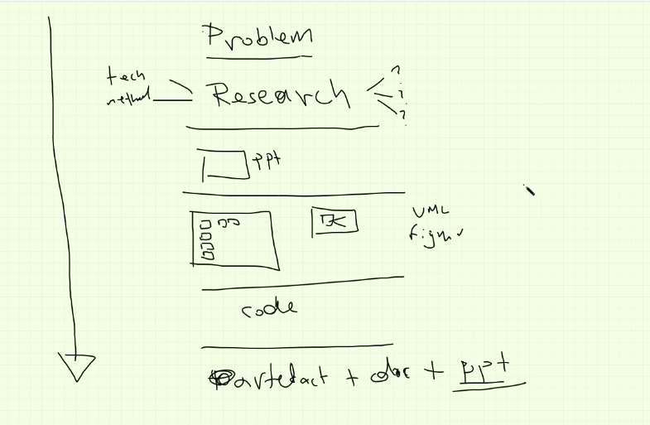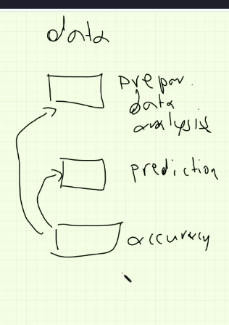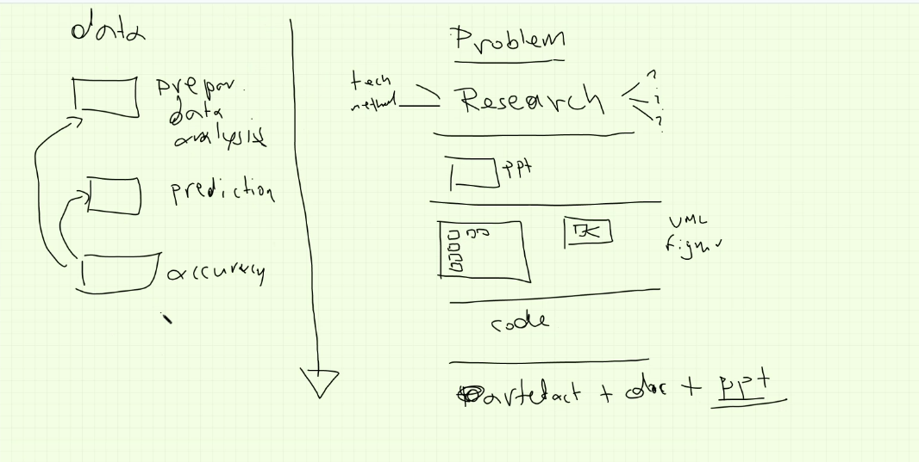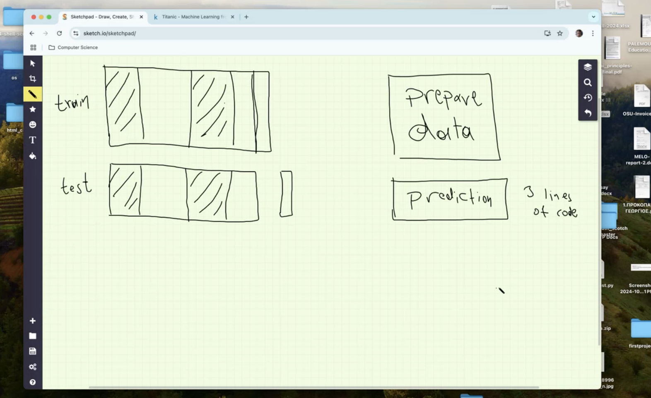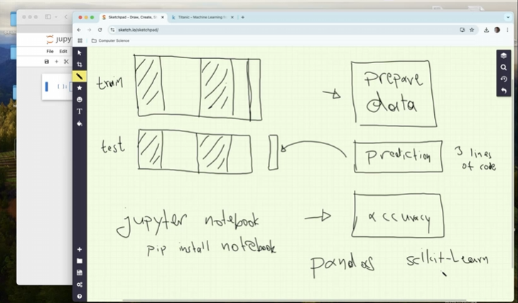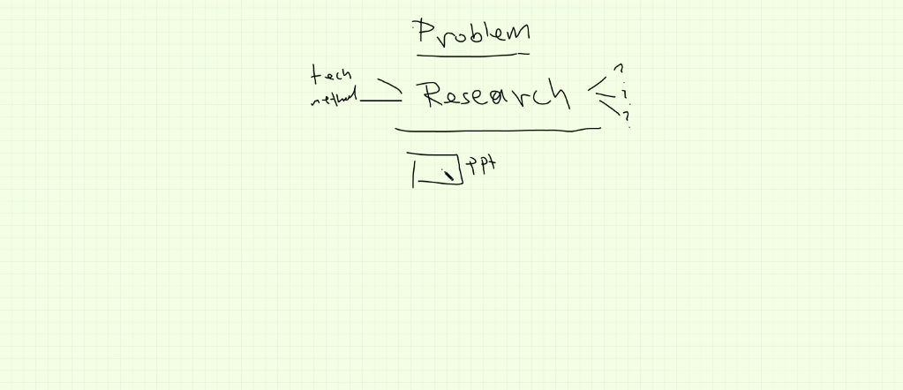

some information that will help

LINK RESEARCH EXAMPLES
https://en.wikipedia.org/wiki/Technological_singularity
https://scikit-learn.org/stable/
https://huggingface.co/bowphs/SPhilBerta
https://arxiv.org/abs/2308.12008
https://github.com/neelguha/legal-ml-datasets.git
https://www.kaggle.com/datasets/amohankumar/legal-text-classification-dataset
Github project examples
legal-ml-datasets-master
https://github.com/neelguha/legal-ml-datasets

Datasets found

